Ross Boyd and Company
SIGMA 33
Northern Ireland Championships
28 July—29 July 2012 Quoile Yacht Club

NOTICE
OF RACE

The Organising Authority of the
Sigma 33 Northern Ireland Championship 2012
is Quoile Yacht Club

SIGMA 33 Northern Ireland Championships
28th – 29th July 2012
QUOILE YACHT CLUB

NOTICE OF RACE

1 RULES
1.1 The regatta will be governed by the rules as defined in The Racing Rules of Sailing.
1.2 The prescriptions of the RYA will apply.
1.3 Racing rules 27.1, A4, 62.1(a), 28.1, 61.3, 62.2, 60.1(a) will be changed. The changes will appear in full in the sailing instructions.
1.4 Rules of the Sigma 33 Offshore One Design Class will apply.
1.5 Entrants may be required to carry sponsors advertising decals.

2 ELIGIBILITY AND ENTRY
2.1 The regatta is open to boats of the Sigma 33 Offshore One Design Class. Owners and Helmsperson must be paid up members of the Sigma 33 OOD Class Association.
2.2 Eligible boats may enter by completing the attached form and sending it, together with the required fee, to Ross Boyd 31 Londonderry Avenue, Comber. Co Down, BT23 5ET. Phone 07801252200
2.3 Late entries will be accepted at the discretion of the Organising Committee, subject to the payment of a late entry surcharge.
2.4 All boats may be inspected for compliance with the Class Rules.

3 FEES
Required fees are as follows: £ 50.00 per Boat £60 after 1 July 2012.

4 SCHEDULE
4.1 Briefing – A Briefing will be held in Quoile Yacht Club at 2000 hrs on Friday 27th July 2012.
4.2 Registration:
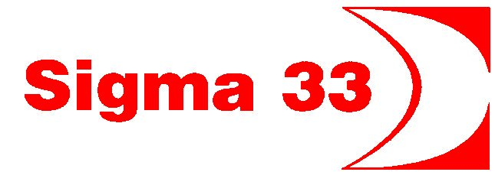

Friday 27 July 2012 From 1900 to 2000 at QYC

SCHEDULE CONTINUED
4.3 Dates of racing:
Date Race
Saturday 28th July Races 1 and 2
Sunday 29th July Races 3, 4 and 5

4.4 The scheduled time of the first warning signal on Saturday is 10:25 and on Sunday is 10:55.

5 SAILING INSTRUCTIONS
The sailing instructions will be available at registration. They will also be available on the QYC web site www.quoileyc.com
SI’s for Race 2 on Saturday will be available on www.strangfordloughregattas.co.uk/ follow link to Killyleagh Regatta Sailing Instructions.

6 SAILING AREA
The Sailing Area will be in Strangford Lough

7 THE COURSES
The Course for Race 1 shall be ‘Round the Lough’ with a gate start.
Saturday Race 2 shall be a ‘Round the Lough’ race as part of Killyleagh Regatta.
The courses for races 3, 4 & 5 shall be Windward-Leeward.

Round the Lough Course marks can be obtained from the SLRC web site http://www.strangfordloughregattas.co.uk/ under KYC Regatta SI’s, also attached to this NOR and the Sailing Instructions.

8 SCORING
8.1 2 races are required to be completed to constitute a series.
8.2 No discards, a boat’s series score will be the total of her race scores.

9 PRIZES. Individual race and overall Series prizes shall be awarded.

10 INSURANCE
Each participating boat shall be insured with valid third-party liability insurance with a minimum cover of £2,000,000 Pounds Sterling or the equivalent.

11 FURTHER INFORMATION
Entrants are encouraged to visit the Club web site www.quoileyc.com to view the club facilities. Information on entering the Lough can be found in the ‘Visiting’ section.
Entrants arriving early from outside the Lough are welcome to leave their yachts on the floating pontoons.
Racing Yachts are invited to moor on the pontoons for the duration of the Event. (In the event of extreme weather boats may have to vacate the pontoons)

Visitors moorings are available.

Names of local guest houses and Hotels are available on request.
The Club has a campsite and visitors are welcome to use it.

For further information please contact:- Ross Boyd 31 Londonderry Avenue, Comber. Co Down, BT23 5ET Phone 07801 252 200

SIGMA SOCIAL EVENTS

Friday 27 July
Bar open from 18:00hrs

Saturday 28th July
Breakfast in the Clubhouse from 08:00 hrs

After racing in Killyleagh Regatta, Crews are invited ashore at Killyleagh for refreshments and Prizegiving.

Please return to QYC before 19:00hrs

Saturday evening traditional BBQ and music/dancing until late.

Sunday 29^{th July}
Breakfast in the Clubhouse from 08:00hrs

Prizegiving after Racing at 16:00hrs.

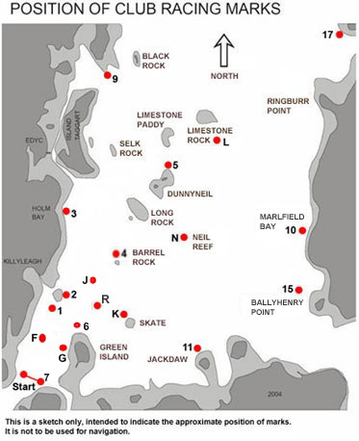

Strangford Lough Race Marks
Note:
• Sunday Race 1 shall start in the area south of mark N
• Saturday Race 2 starts at Killyleagh in vicinity of Mark 1
• Races 3, 4 & 5 shall take place in the area generally south of Mark N
• Ignore ‘Start’ on chart in vicinity of Mark 7

SIGMA 33 Northern Ireland Championships
28th – 29th July 2012
QUOILE YACHT CLUB
ENTRY FORM
Send this form, together with cheque to :-

Declaration
I wish to enter the above named boat in the 2012 Sigma 33 OOD Class NI Championships and I agree to be bound by the Racing Rules of Sailing, the Sigma 33 OOD Class Rules (where applicable) the Sailing Instructions and all other rules that govern this event. I accept that the participation of the above named boat in the championships is at my sole and exclusive risk in every respect. By this entry I hereby indemnify the Quoile Yacht Club, and their officers, members, servants agents and the Sigma 33 OOD Class Association in respect of all claims and demands of whatever nature which may be made upon them in connection with or howsoever arising from the participation or intended participation of the above named boat in the championships, and I acknowledge that the Quoile Yacht Club, and their officers, servants and agents accept no responsibility in respect of loss of life, personal injury or loss of or damage to property which I or any other person may sustain by reason of the participation or intended participation of the above named boat in these championships or howsoever arising in connection with this event.

I confirm that my boat carries adequate valid third party liability insurance cover.

Signed: _______________________________________________________ Date ____________________

(Owner, authorised representative, as appropriate)
Ross Boyd, 31 Londonderry Avenue, Comber. Co Down, BT23 5ET. Phone 07801 252 200

Sail No. _________________ Boat Name ________________________________

Helm __________________________________

Club _______________________________ _

Address _____________________________________________________________________

Phone (H) __________________________ (O) __________________________ (Fax) _________________

Mobile __________________________ Email ______________________________ _____________

I enclose Cheque payable to QYC for the following:
Entry Fee £ 50.00
Late Entry Fee (after 1 July 2012 additional) £10.00 £ _________
Total £ ________
To assist with Catering, please give approximate
number of crew/guests attending the Saturday evening BBQ/Social function

CLUB MEMBERSHIP
All Helmsmen and their crews competing in these championships will be Temporary Members of the Quoile Yacht Club for the duration of the event and will be bound by the rules of the Club.

Declaration
I wish to enter the above named boat in the 2012 Sigma 33 OOD Class NI Championships and I agree to be bound by the Racing Rules of Sailing, the Sigma 33 OOD Class Rules (where applicable) the Sailing Instructions and all other rules that govern this event. I accept that the participation of the above named boat in the championships is at my sole and exclusive risk in every respect. By this entry I hereby indemnify the Quoile Yacht Club, and their officers, members, servants agents and the Sigma 33 OOD Class Association in respect of all claims and demands of whatever nature which may be made upon them in connection with or howsoever arising from the participation or intended participation of the above named boat in the championships, and I acknowledge that the Quoile Yacht Club, and their officers, servants and agents accept no responsibility in respect of loss of life, personal injury or loss of or damage to property which I or any other person may sustain by reason of the participation or intended participation of the above named boat in these championships or howsoever arising in connection with this event.

I confirm that my boat carries adequate valid third party liability insurance cover.

Signed: _______________________________________________________ Date ____________________

(Owner, authorised representative, as appropriate)

